
Maria Cuellar
Assistant Professor
Department of Criminology
University of Pennsylvania
483 McNeil, 3718 Locust Walk, 483B
Philadelphia, PA, 19104
mcuellar@sas.upenn.edu
(646) 463-1883
May 27, 2026

To whom it may concern:

This letter is to confirm my support for Stoney Forensic, Inc., regarding their proposed research on the use of non-identifiable fingermarks (NIFMs) for cold case investigations. I will support this research as a consultant, providing statistical review and expertise.

Firstly, over the course of three years, I will be reviewing the technical deliverables (in an advisory role) for their quality and relevance with respect to statistical data analysis as applied to forensic science. This will include review of the research performance progress reports (every six months) as well as annual reports, publications, and presentations. This review effort is estimated at approximately 20-22 hours per year at a rate of $81.25/hr ($650 per 8 hour day) over the course of three years.

Secondly, I will be available for additional work during this period (at the same rate, up to 80 additional hours annually) to directly oversee or conduct experimental design and statistical analyses relating to the testing of the investigative protocols and assessment of performance metrics.

I anticipate that I will be included as a co-author on research presentations and publications that are based on this work.

Sincerely,

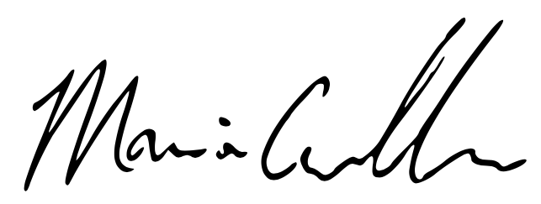
Maria Cuellar
Assistant Professor
Department of Criminology

